- Create a tomcat container on 8080 and deploy sample application in tomcat.
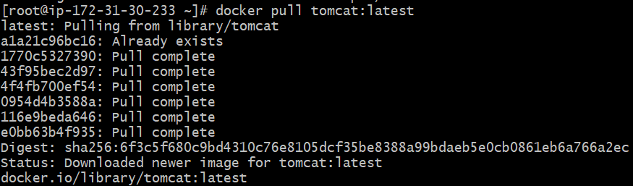
-itd: Interactive terminal background (Running the image in background)
-p: Specific port number
8081:8080: Host port (8081), Image exposed at (8080)
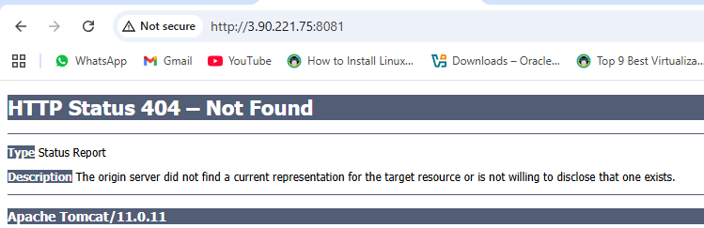
404 error means there is no deployment file is available (webapps).
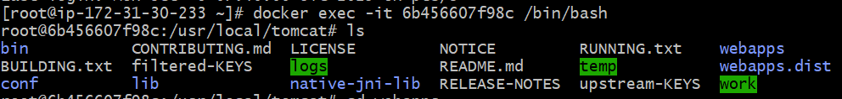
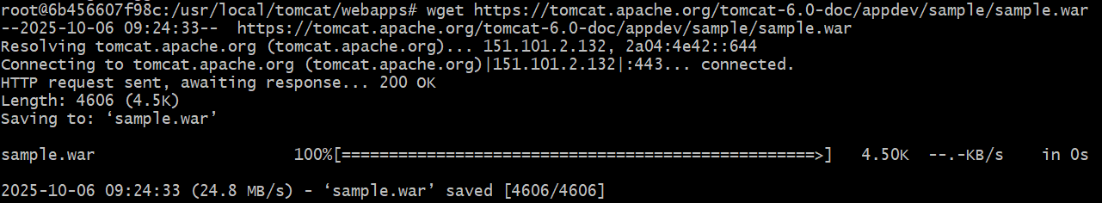
We have downloaded the sample.war file.
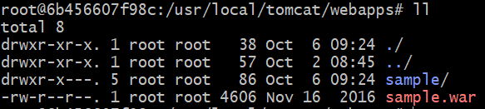
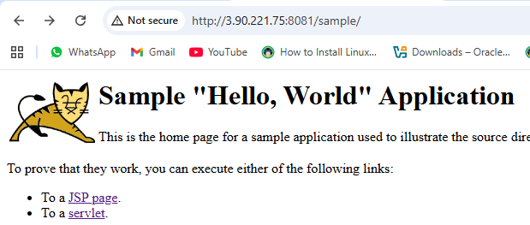
- Create volume and deploy tomcat container on port 8081.
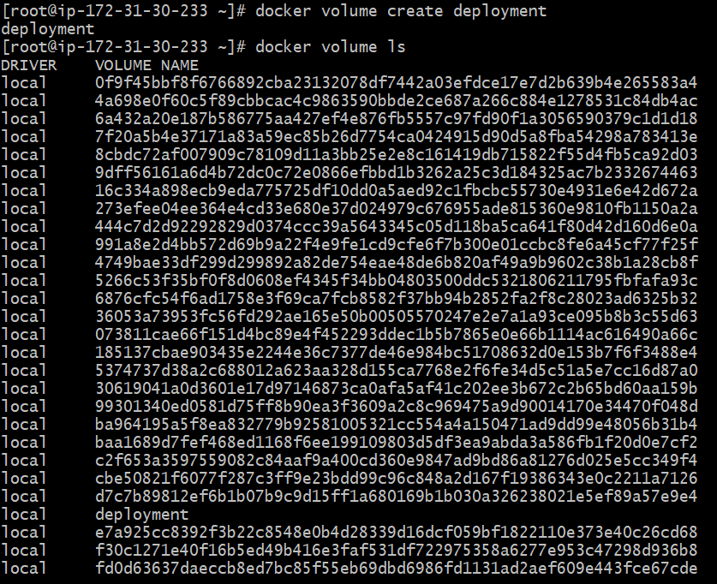
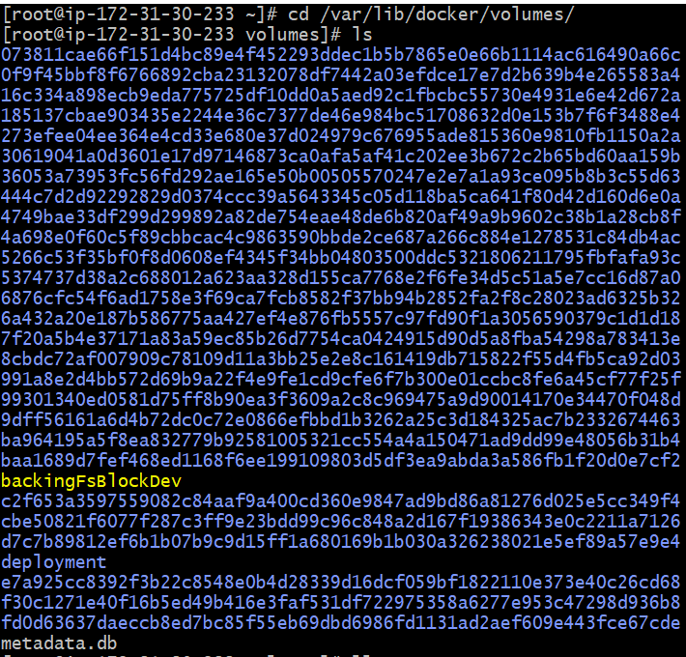
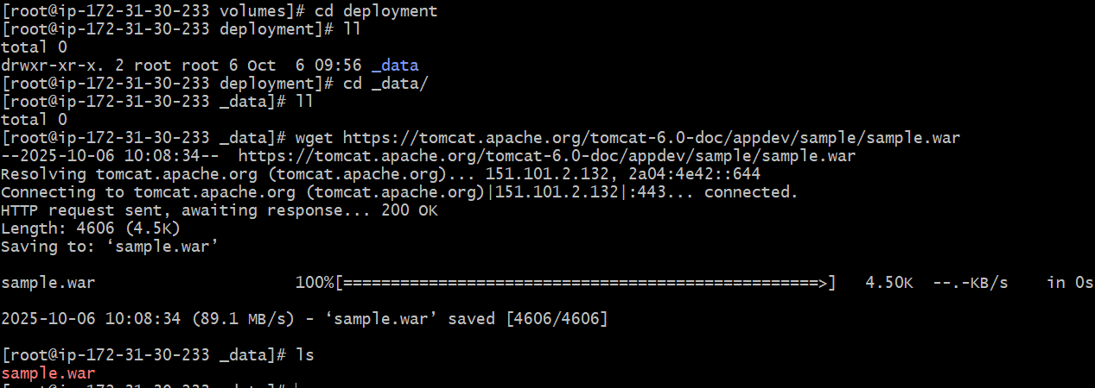
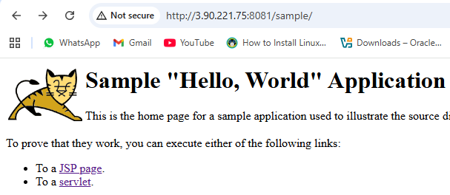
- Limit the nginx container to 500 MB.
By limiting the size can save the system memory as well as the performance of the machine to load the other files.
- Create a sample docker file using below instructions.
  - Base module as amazonlinux:latest
  - Maintainer you name
  - Install nginx
  - COPY one index.html file to image
  - Expose on port 80
  - Command to start the nginx container
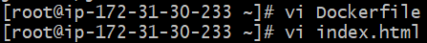
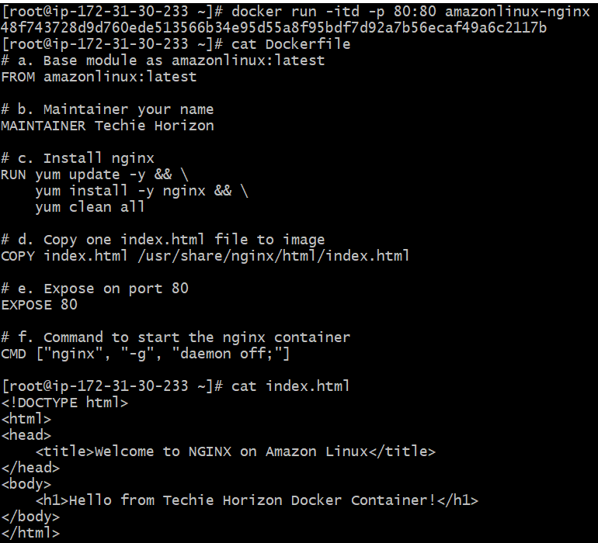
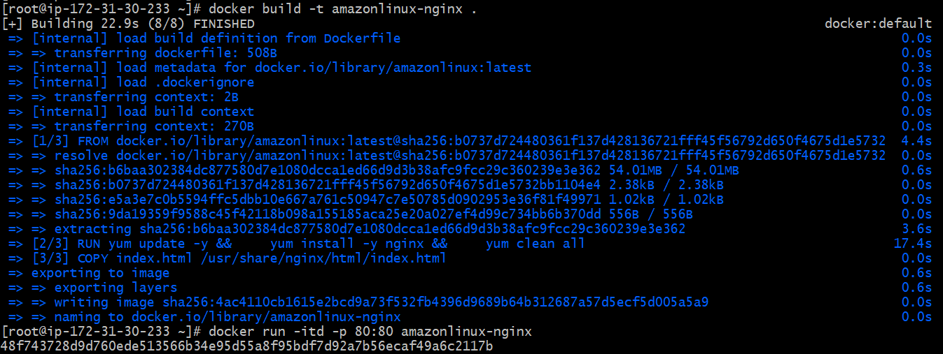
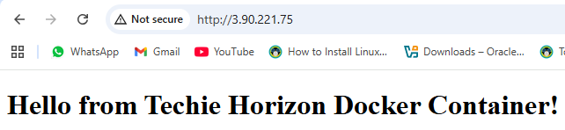
- Push image to Docker hub
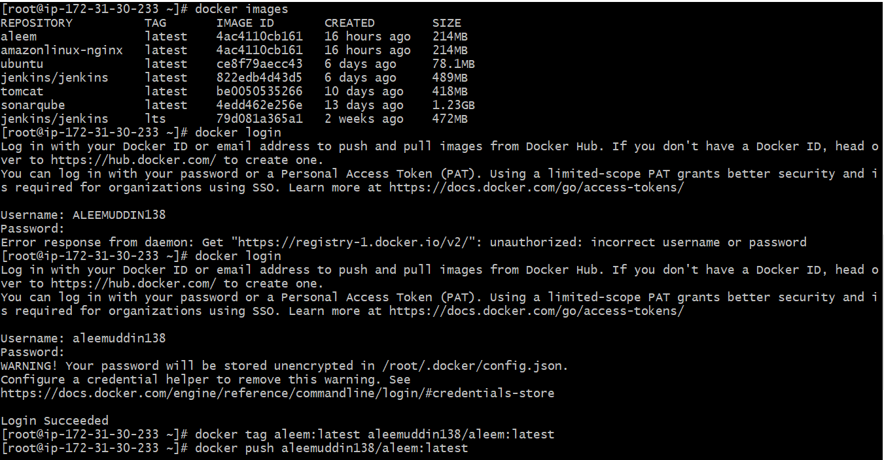
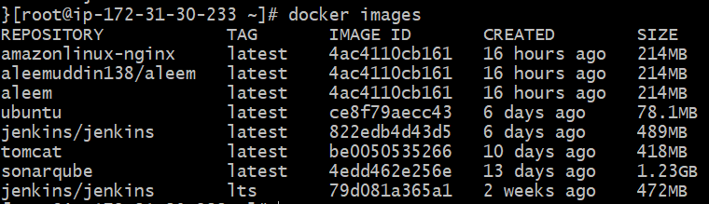
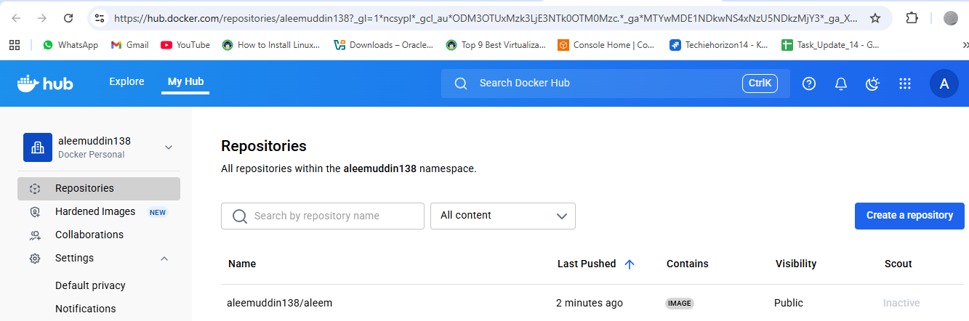
- push image to AWS ECR
AWS CLI installed and configured with credentials
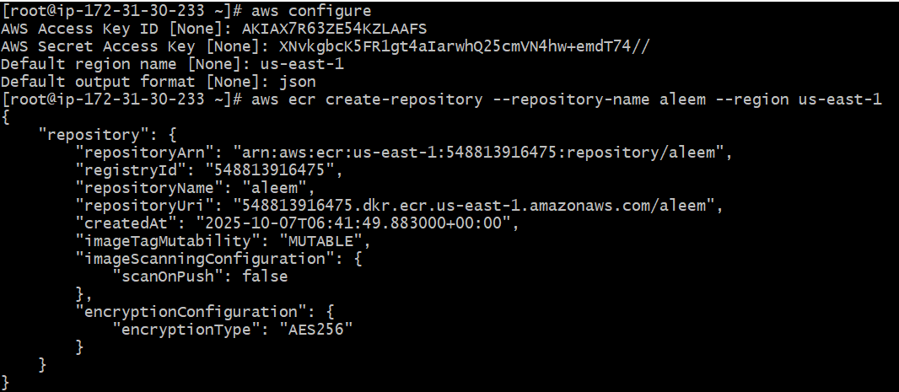Create the repository first
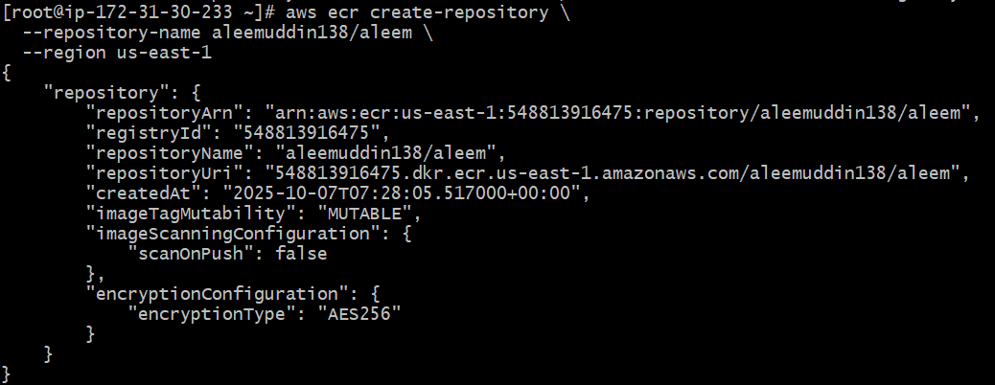
Authenticate Docker to ECR
Define AWS region and account ID
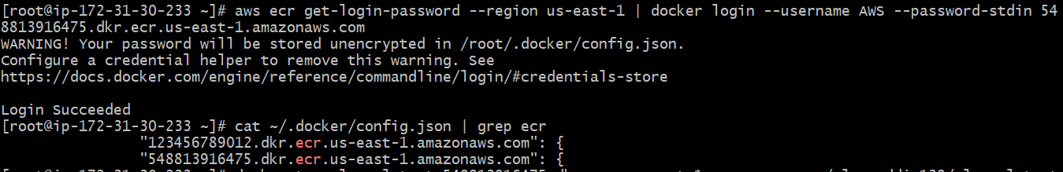
Tag your Docker image
Push the image to ECR
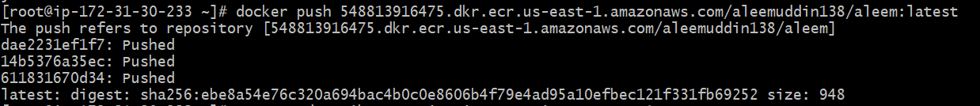
check the AWS Management Console → ECR → Repositories → aleem
